# Bitwise Operators Assignment

**Mandatory**

Q1. WAP to read a 8 bit unsigned integer, interchange the adjacent bits i.e D0  with D1, D2 with D3….. D6 with D7.  Display the final number.

Input: 0xAA

Output: 0x55

Q2. WAP to count the number of 1’s in a given byte and display

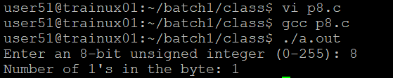

Q3. Generate odd and even parity bits for a given number. (consider a 32 bit number)

[Hint: You may reuse the solution created in Q2 and extend it further]

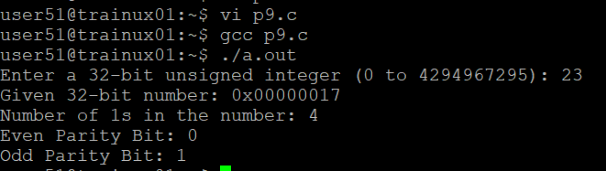

Q4. WAP to reverse the bytes in a 32 but unsigned integer using shift operator.

Input: 0x12345678

Output: 0x78563412

